Introduction to Data Management
PROJECT REPORT
(Project Semester January-April 2025)

Demographic Analysis of Suicide Mortality Rates in the United States: An Interactive Dashboard Approach

Submitted by

Anubhav Singh Registration No: 12307500 Section: K23EG
Programme: B. Tech - Computer Science and Engineering Course Code: INT217

Under the Guidance of

Jaffar Amin Chacket (UID: 30453) Discipline of CSE/IT

Lovely School of Computer Science and Engineering Lovely Professional University, Phagwara



CERTIFICATE

This is to certify that Anubhav Singh bearing Registration no. 12307500 has completed INT217 (Introduction to Data Management) project titled, “Demographic Analysis of Suicide Mortality Rates in the United States: An Interactive Dashboard Approach” under my guidance and supervision. To the best of my knowledge, the present work is the result of his/her original development, effort and study.

Signature
Jafar Amin Chacket (UID: 30453) Designation of the Supervisor
School of Computer Science and Engineering
Lovely Professional University Phagwara, Punjab.

Date:

DECLARATION

I, Anubhav Singh, student of B.Tech Computer Science and Engineering under CSE/IT Discipline at, Lovely Professional University, Punjab, hereby declare that all the information furnished in this project report is based on my own intensive work and is genuine.

Manab Khanra 12307500-K23EG
B. Tech - Computer Science and Engineering Lovely Professional University, Phagwara


09/04/2025

Acknowledgement

The opportunity of attaining a course based on Data Management using Excel at Lovely Professional University was worth learning. It was a prestige for me to be part of it. During the period of my course, I received tremendous knowledge related to Microsoft Excel and Data Management.
Pre-eminently, I would like to express my deep gratitude and special thanks to my course teacher Jaffar Amin Chacket his theoretical knowledge and encouragement on this project and for her valuable guidance and affection for the successful completion of this project.
Secondly, I would like to thank Lovely Professional University for giving me an opportunity to learn this course.
Lastly, I would like to thank the almighty and my parents for their constant encouragement, moral support, personal attention, and care.

Anubhav Singh
12307500-K23EG
B. Tech - Computer Science and Engineering Lovely Professional University, Phagwara


Contents

Sr. No. | Topic | Page No.
1. | Cover Page | 1
2. | Certificate | 2
3. | Declaration | 3
4. | Acknowledgement | 4
5. | Contents | 5
6. | Abstract | 6
7. | List of Tables and Figures | 7
8. | Chapter 1 - Introduction | 8
9. | Chapter 2 - Objectives | 9
10. | Chapter 3 - Source of Dataset | 10
11. | Chapter 4 - Dataset Preprocessing | 11-13
12. | Chapter 5 - Analysis on dataset | 14-22
13. | Chapter 6 - Dashboard | 23-26
14. | Chapter 7 - Conclusion | 27
15. | Chapter 8 - Future scope | 28-29
16. | Chapter 9 - References | 30

Abstract

Excel is a software program created by Microsoft that uses spreadsheets to organize numbers and data with formulas and functions. Excel analysis is ubiquitous around the world and used by businesses of all sizes to perform data analysis. Excel features calculation, graphing tools, pivot tables, and a macro programming language called Visual Basic for Applications, and several other features which make Excel a perfect choice to manage and analyse data.
My project is an Excel Dashboard. The Excel Dashboard is used to display overviews of large data tracks. Excel Dashboards use dashboard elements like tables, charts, and gauges to show the overviews. The dashboards ease the decision-making process by showing the vital parts of the data in the same window.
In this report, I have shared a project where I have done data analysis of a Suicide Rate dataset across US States. This report also presents my learning during my course classes.

List of Tables and Figures

Sr. No. | Table and Figure Name | Page No.
1. | Raw Data | 12
2. | Clean Data | 12
3. | Calculated columns | 13
4. | Cleaned dataset sheet with columns for easy accessibility | 15
5. | Pivot Tables to analyse suicide rates | 16
6. | Suicide rates with respect the sex | 17
7. | Suicide rates with respect the age-group | 18
8. | Bar Chart | 19
9. | Pie Chart | 20
10. | Line Chart | 20
11. | Stack Bar Chart | 21
12. | Donut Chart | 21
13. | Final Dashboard | 22
14. | Analysing data using slicers | 22-25

Chapter 1 - Introduction

I have created an Excel Dashboard of a Suicide Rate dataset across US States. This dashboard explains and highlights important facts, trends, and patterns related to suicide rates in different states based on gender, race, age group, and year.
The dataset used contains information regarding suicide death rates in the United States. It includes details such as gender-wise data, race-wise data, Hispanic origin, and different age groups of people affected by suicide. The dataset also covers records from multiple years across various US states.
I have scrubbed and organized the entire dataset and performed the analysis on a clean data sheet created within the Excel workbook. I have derived and calculated important results from the dataset using various Excel features like pivot tables, slicers, and functions. I have represented the findings in the form of a dynamic dashboard using Excel's visualization tools and various charts.

Chapter 2 - Objectives

This project on Suicide Rate Analysis provides the records, facts, and trends of suicide rates across US States with respect to gender, race, age group, and year. However, here are the few main objectives that are discussed in the dashboard:
- Showing the total number of suicide cases and their distribution with respect to gender, race, age group, year, and state.
- Showing the performance and comparison of states overall, or in a particular year, based on gender-specific suicide rates.
- Showing the distribution and trends of suicide rates among different age groups.

- Highlighting the gender-wise comparison of suicide rates overall, or in specific states, or particular years.
- Showing the trend analysis of suicide rates over the years based on different states and demographic groups.
- Displaying the most affected age groups and races in terms of suicide rates.

- Highlighting the state-wise contribution to the total number of suicide cases.

- Visualizing the overall trends and patterns to provide meaningful insights for decision-making and awareness.

Chapter 3 - Source of Dataset

The dataset is taken from Data.gov. Data.gov is the official open data portal of the United States Government that provides access to a wide range of datasets for public use. This platform allows users to find and download datasets published by government agencies.
I have selected a Suicide Rate dataset which contains important details of suicide rates across the United States categorized by gender, race, age group, and year.
Here are the details of my chosen dataset:

Name - Death Rates for Suicide by Sex, Race, Hispanic Origin, and Age — United States Link - https://catalog.data.gov/dataset/death-rates-for-suicide-by-sex-race-hispanic-origin- and-age-united-states-020c1
Format - CSV Data Fields:
- INDICATOR — (String) — Description of the indicator measured

- UNIT — (String) — Unit of measurement (e.g., Rate per 100,000 population)

- UNIT_NUM — (Numeric) — Numerical code for unit type

- STUB_NAME — (String) — Classification by sex and race

- STUB_NAME_NUM — (Numeric) — Numerical code for STUB_NAME

- STUB_LABEL — (String) — Label for STUB_NAME category

- STUB_LABEL_NUM — (Numeric) — Numerical code for STUB_LABEL

- YEAR — (Integer) — Year of data record

- YEAR_NUM — (Numeric) — Numerical representation of year

- AGE — (String) — Age group category

- AGE_NUM — (Numeric) — Numerical representation of age group

- ESTIMATE — (Numeric) — Death rate estimate per specified population

Chapter 4 - Dataset Preprocessing

In this project, the dataset preprocessing was an important step to ensure accurate and meaningful analysis. The dataset was downloaded from the official United States Government Open Data Portal (Data.gov). The raw dataset contained information about suicide death rates in the United States categorized by gender, race, age group, and year.
The following preprocessing steps were performed:

- Data Cleaning:

  - Removed unnecessary columns that were not required for analysis.

  - Identified and handled missing values in important columns.

  - Replaced blank cells or missing entries with appropriate values where applicable.

- Data Transformation:

  - Renamed column headers for easy understanding and readability.

  - Organized data into a clean and structured format suitable for analysis.

  - Filtered relevant records and removed inconsistent data entries.

- Creating Clean Dataset Sheet:

  - After cleaning and transforming the data, a new sheet named "Clean Dataset" was created within the Excel workbook.
  - The following screenshots represent:

  - 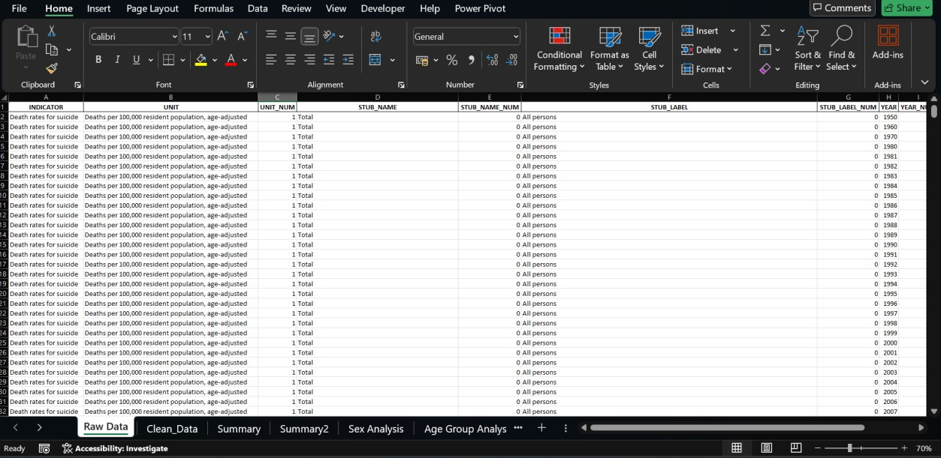

Figure 1: The original/raw dataset imported from Data.gov.
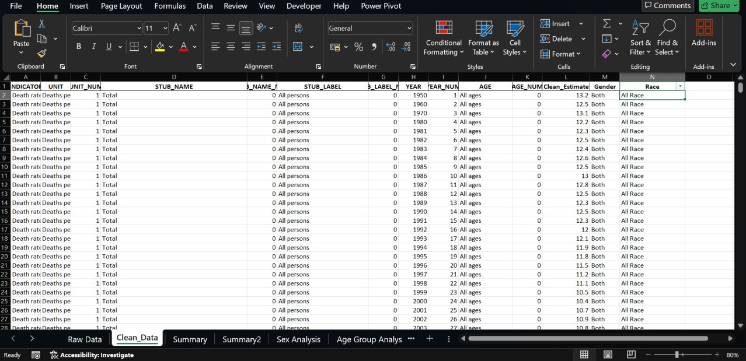

Figure 2: The cleaned dataset sheet created after data preprocessing.

  - This clean dataset sheet was used as the primary source for performing analysis and creating visualizations in the dashboard.
- Data Preparation:

  - Created calculated columns for better analysis (e.g., calculating total suicide rates, average rates, etc.).
  - This screenshot represent:

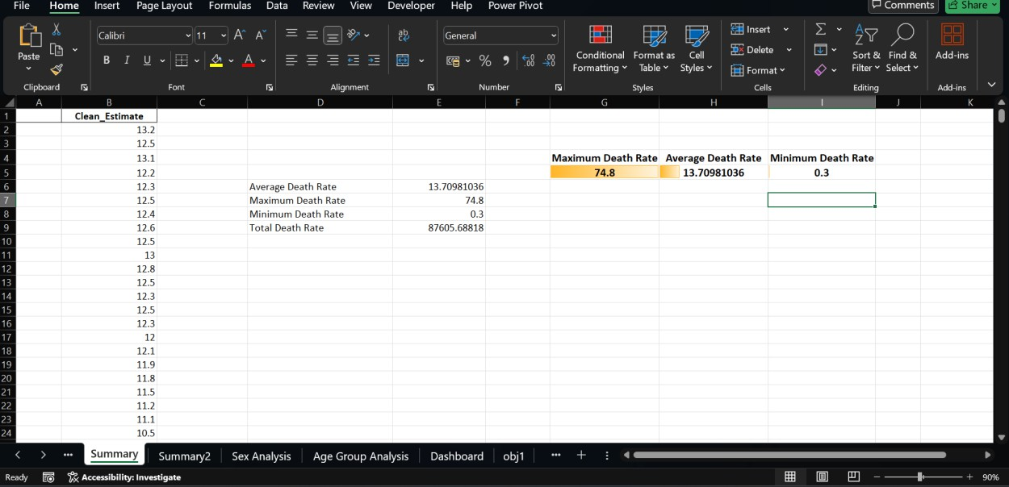

Figure 3: The calculated columns for better analysis

  - Used sorting and filtering techniques to analyze specific data points.

This preprocessing phase ensured that the dataset was accurate, consistent, and ready for further analysis using Excel tools like Pivot Tables, Charts, Slicers, and Conditional Formatting.

Chapter 5 - Analysis on dataset

  - General Description:

The dataset provides detailed information about suicide death rates across the United States. It covers various aspects and demographic details like gender, race, Hispanic origin, age group, and year-wise data. This comprehensive dataset allows for the observation of patterns and analysis of trends in suicide rates over different time periods and across various states.
This project focuses on analyzing how suicide rates vary between different groups of people. The data helps in identifying which states have higher suicide rates, the comparison between male and female suicide rates, the most vulnerable age groups, and the differences in suicide rates among different races and ethnic groups.
The dataset also enables the study of the changing patterns of suicide rates over the years, highlighting any increase or decrease based on several factors. The clean dataset sheet was created to ensure that the data was accurate, consistent, and structured properly for effective analysis. Various Excel tools like Pivot Tables, Charts, Slicers, and Conditional Formatting were used to generate insights and represent them visually through a dynamic dashboard.
This analysis provides meaningful information that can help researchers, policymakers, and healthcare planners understand the suicide trends in the United States and make data-driven decisions to address this serious issue. The clean dataset was used to generate insights and create various visualizations for the dashboard.

  - Specific Requirements:
The specific requirements of this project were to analyze the suicide rate dataset and provide meaningful insights using Excel. The project aimed to use the capabilities of Excel to turn raw data into understandable and visually engaging insights through a dashboard. The analysis and dashboard creation were focused on enabling easier decision-making and presenting key data in an effective way.
The main requirements included:

  - Cleaning and transforming the raw dataset for accurate and meaningful analysis.

  - Creating a separate clean dataset sheet within the Excel workbook for structured analysis and easy accessibility.
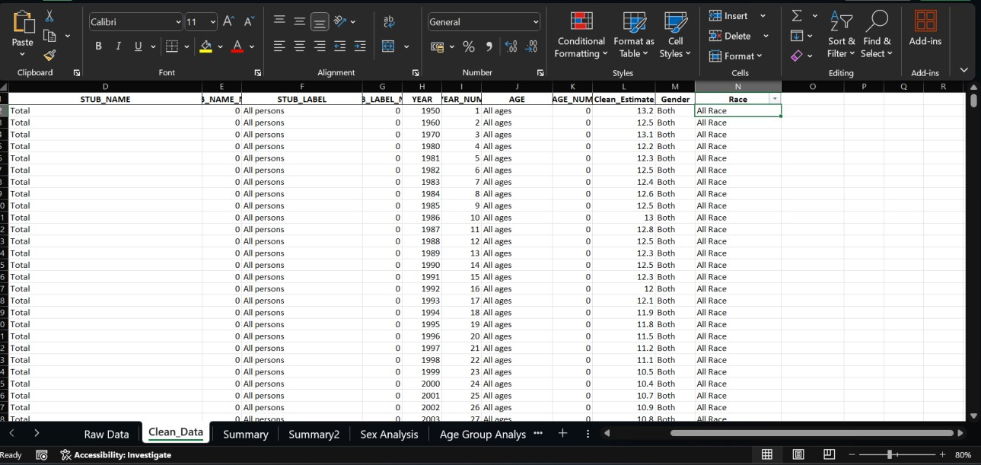

Figure 4: The cleaned dataset sheet with columns for easy accessibility

  - Generating pivot tables to analyse suicide rates state-wise, gender-wise, race-wise, and age-wise.
  - Designing various charts like bar charts, line charts, pie charts, and heatmaps to visualize different aspects of the data.
  - Incorporating slicers to filter the dataset interactively based on parameters like year, state, gender, and age group.
  - Highlighting key performance indicators (KPIs) like states with the highest suicide rates, lowest suicide rates, and average suicide rates across the dataset.

  - Ensuring the dashboard is dynamic, user-friendly, and provides a comprehensive overview of the data.
  - Utilizing conditional formatting to visually emphasize significant values and trends in the data.
These requirements were fulfilled using Excel tools and functions, ensuring an effective analysis of the dataset and the creation of a dynamic and insightful dashboard that can help users better understand suicide trends in the United States and facilitate data-driven decision-making.

  - Analysis results:

Based on the analysis of the suicide rate dataset using Excel, the following key results and insights were obtained:
    - Gender-wise analysis revealed that the suicide rates were generally higher among males compared to females across most states and years. This insight highlights the importance of creating gender-specific mental health programs to address the issues faced predominantly by the male population.
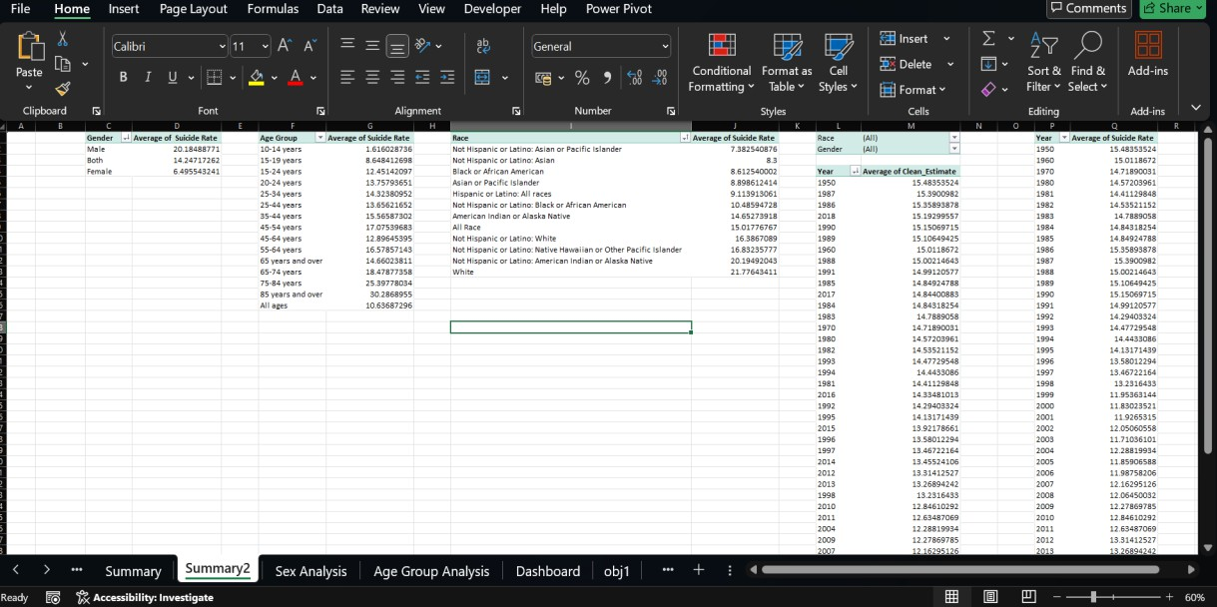
Figure 5: Pivot Tables to analyse suicide rates state-wise, gender-wise, race-wise, and age-wise.

    - Age-wise analysis highlighted that certain age groups were more vulnerable to suicide, particularly middle-aged and elderly populations in some regions. The analysis also provided insights into the need for special attention and mental health support for younger populations to prevent future increases in suicide rates.
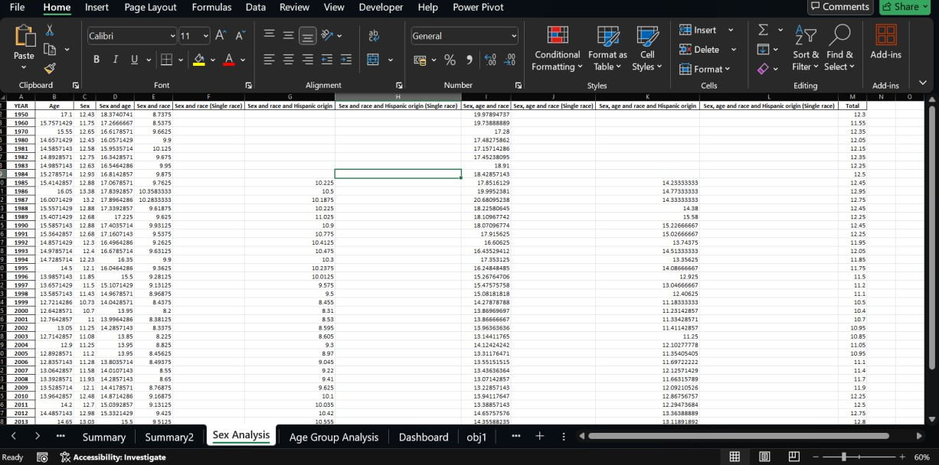

Figure 6: The representation of suicide rates with respect the sex

    - Race and Hispanic origin analysis helped identify disparities in suicide rates among different racial groups, emphasizing the need for targeted mental health programs that cater to the unique cultural and social challenges faced by each group.
    - Year-wise trend analysis showed variations in suicide rates over time, providing valuable insights into whether the rates increased, decreased, or remained stable in specific states or demographic categories. These trends help understand the effectiveness of past mental health initiatives and provide a base for planning future programs.

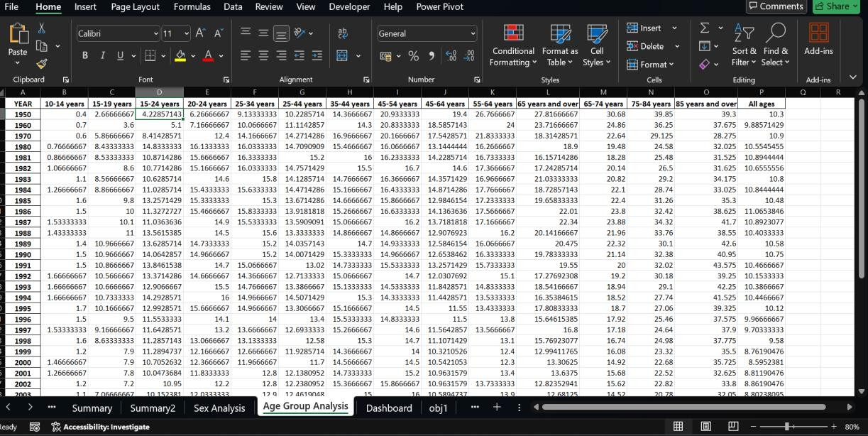

Figure 7: The representation of suicide rates with respect the age-group

    - The use of slicers and KPIs in the dashboard allowed users to interactively filter the data and focus on specific areas of interest, enhancing the overall analytical experience. The interactivity of the dashboard enables users to make quick and informed decisions by analysing different segments of the dataset.
These results provide a clear understanding of suicide rate patterns across the United States and support data-driven decision-making for awareness campaigns and preventive measures. The analysis also showcases the significance of using Excel's powerful features for handling large datasets and converting them into useful insights for practical applications.

  - Visualization:
This section presents the visualizations created during the analysis of the Suicide Rate dataset using Excel. These visualizations provide a clear and interactive representation of the data for better understanding and decision-making.
The following visualizations were created:

    - Bar Chart: Comparison of Average Suicide Rate based on Gender

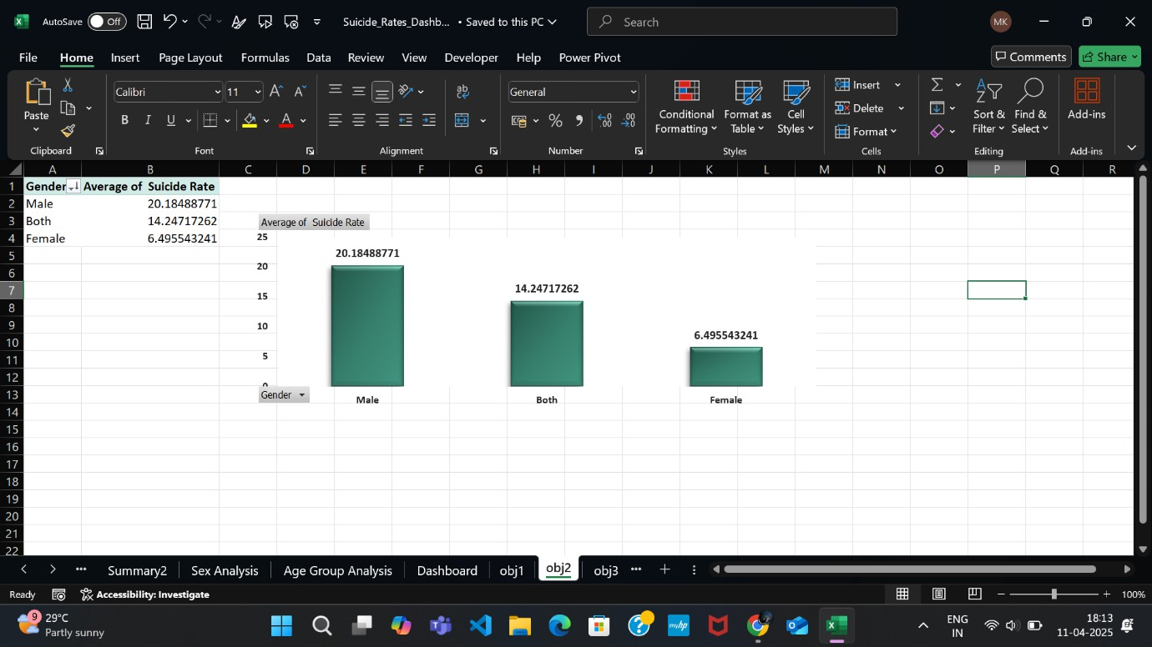

Figure 8: Bar Chart of Average Suicide Rate based on Gender

    - Pie Chart: Gender-wise Suicide Rate Distribution

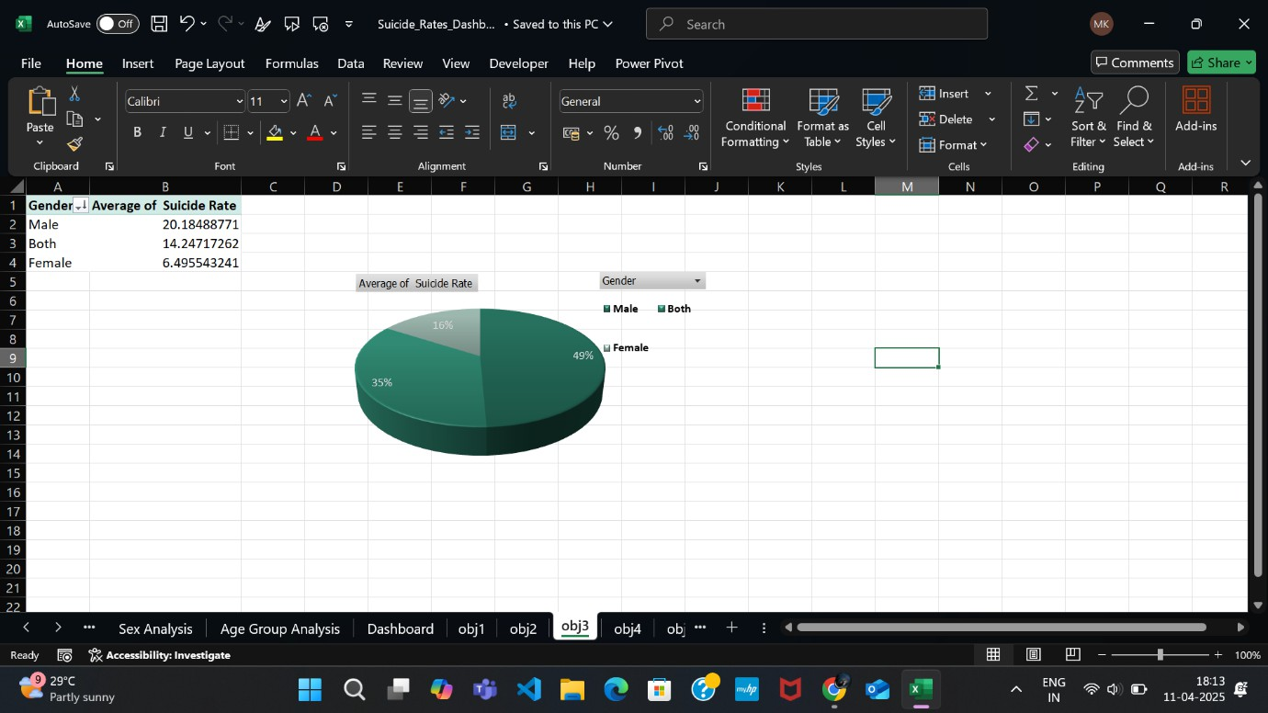

Figure 9: Pie Chart of Gender-wise Suicide Rate Distribution

    - Line Chart: Year-wise Suicide Rate Trend Analysis

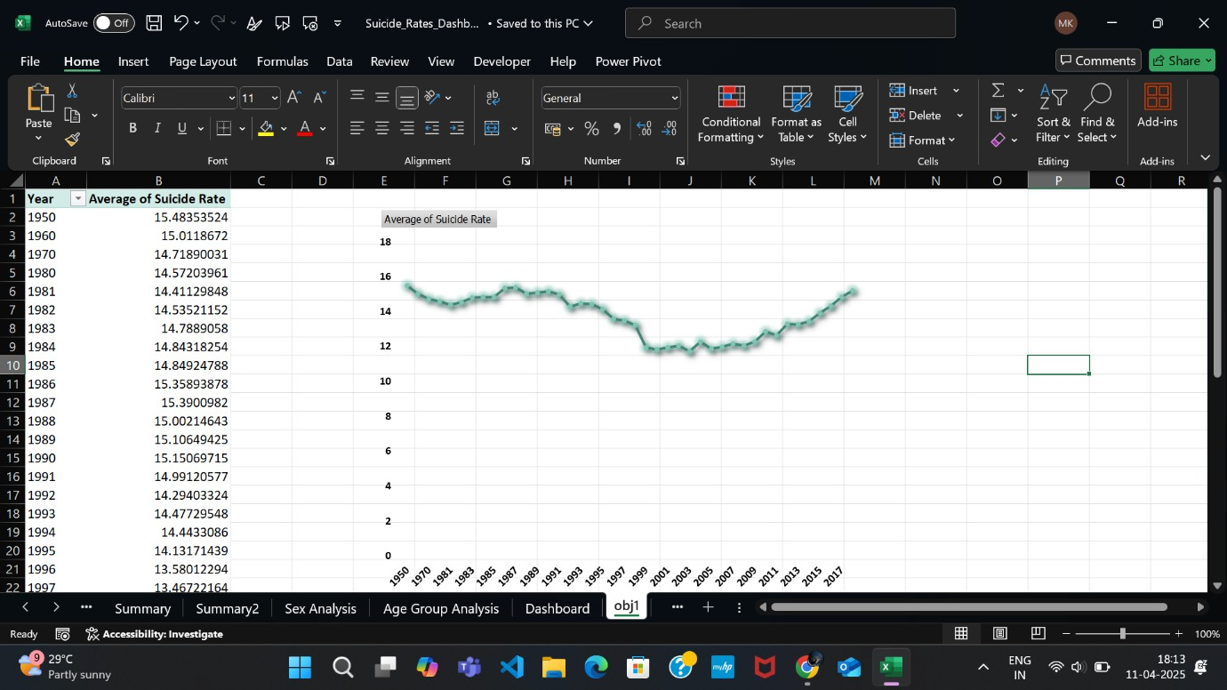

Figure 10: Line Chart of Year-wise Suicide Rate Trend Analysis

    - Stacked Bar Chart: Comparison of Suicide Rate across Different Races
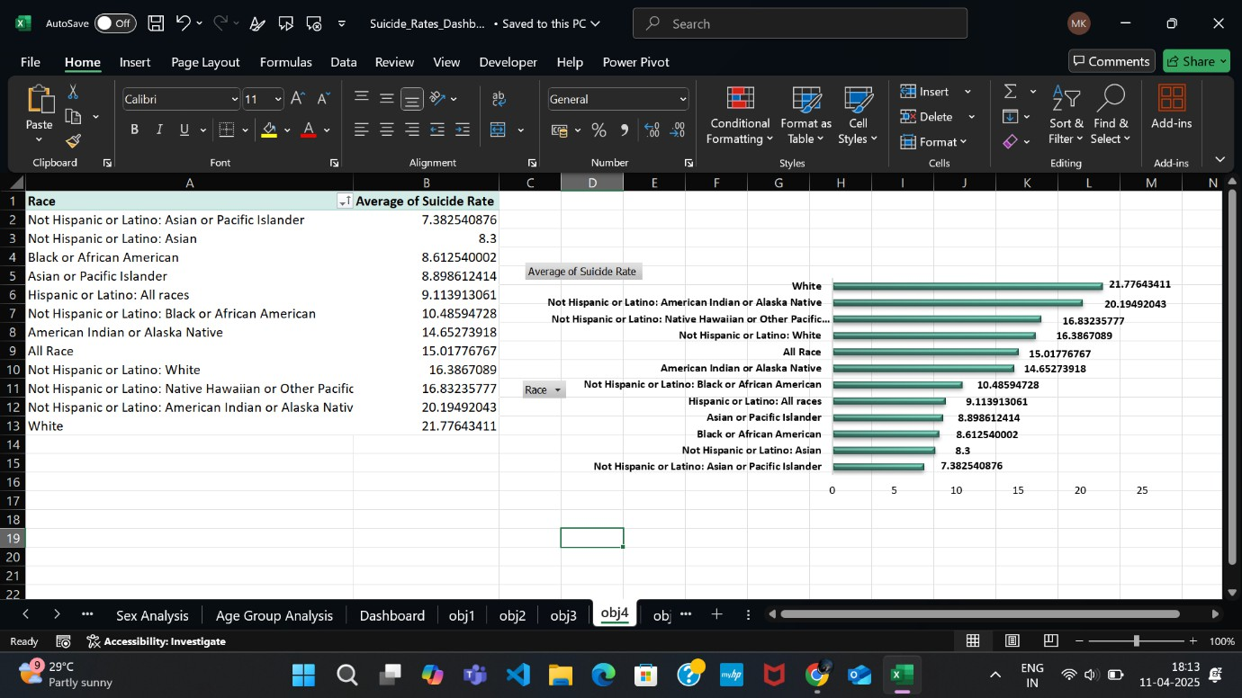

Figure 11: Stack Bar Chart of Comparison of Suicide Rate across Different Races

    - Donut Chart: Distribution of Suicide Rate based on Age Groups
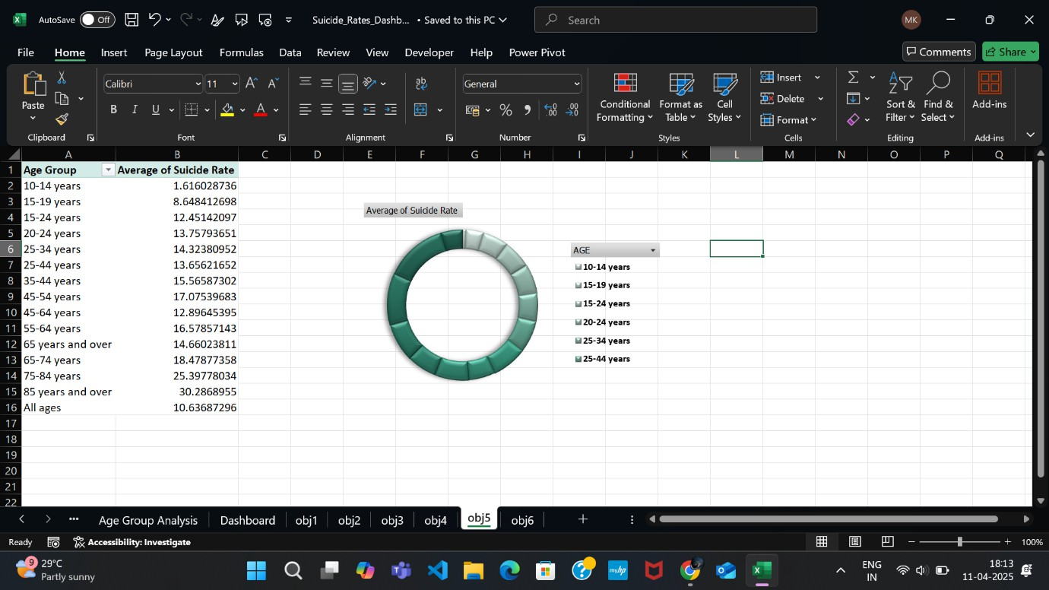

Figure 12: Donut Chart of Comparison of Distribution of Suicide Rate based on Age Groups

These charts and visuals helped to represent the key insights obtained from the dataset in a visually appealing and user-friendly manner. They allow users to quickly interpret the results and focus on critical areas for better analysis and reporting.

Chapter 6 - Dashboard

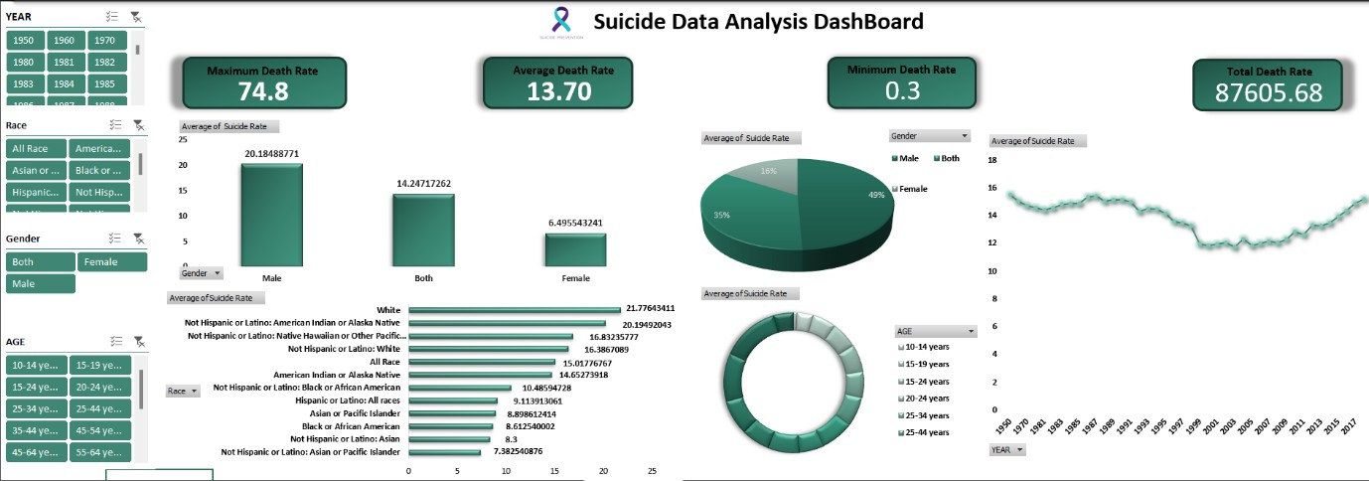

Figure 13: Final Dashboard

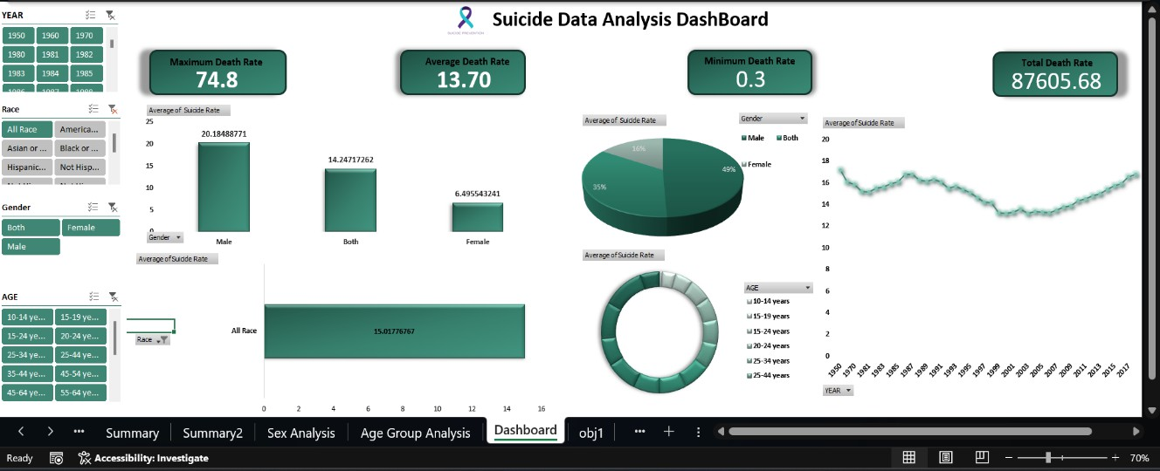

Figure 14: Analysing data using slicers

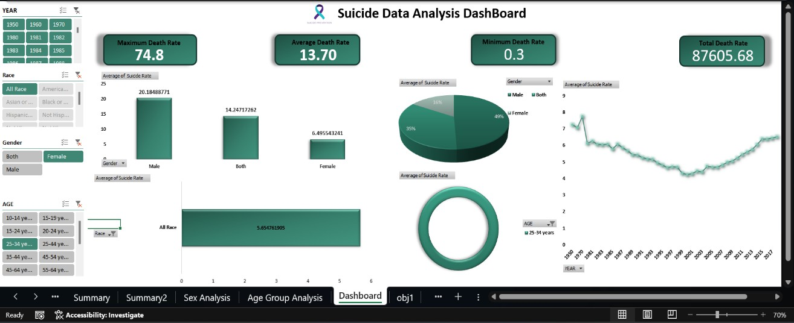

Figure 15: Analyzing data using slicers

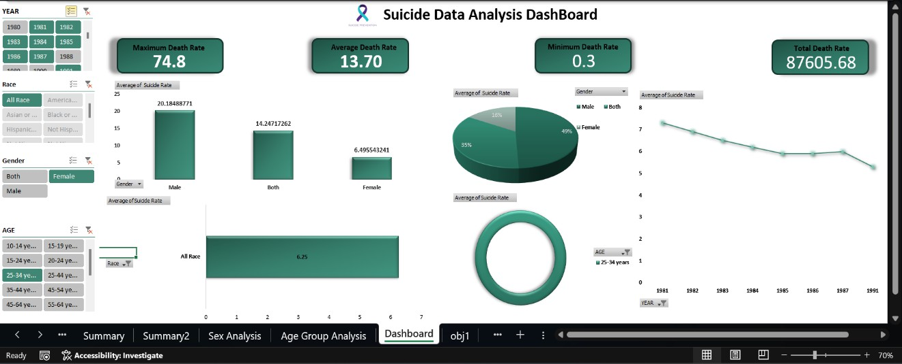

Figure 16: Analyzing data using slicers

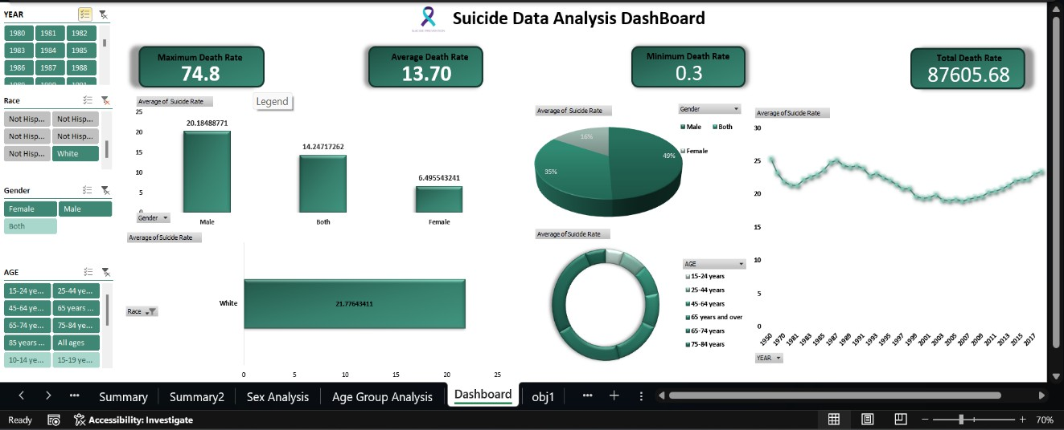
Figure 17: Analyzing data using slicers

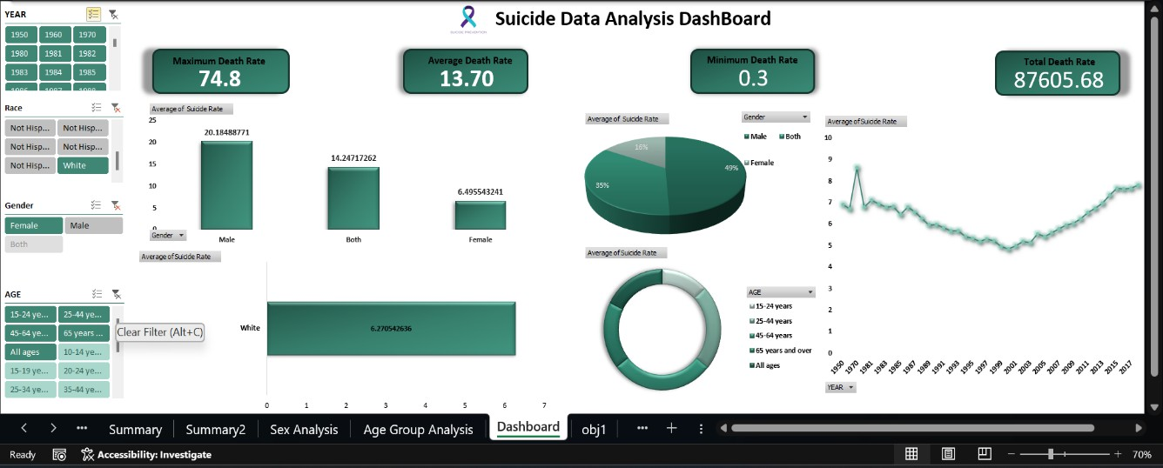

Figure 18: Analyzing data using slicers

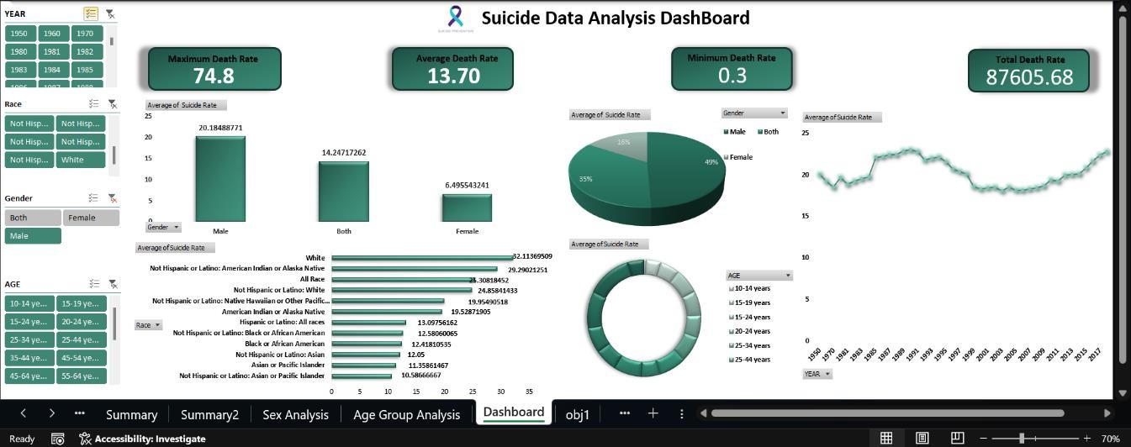

Figure 19: Analyzing data using slicers

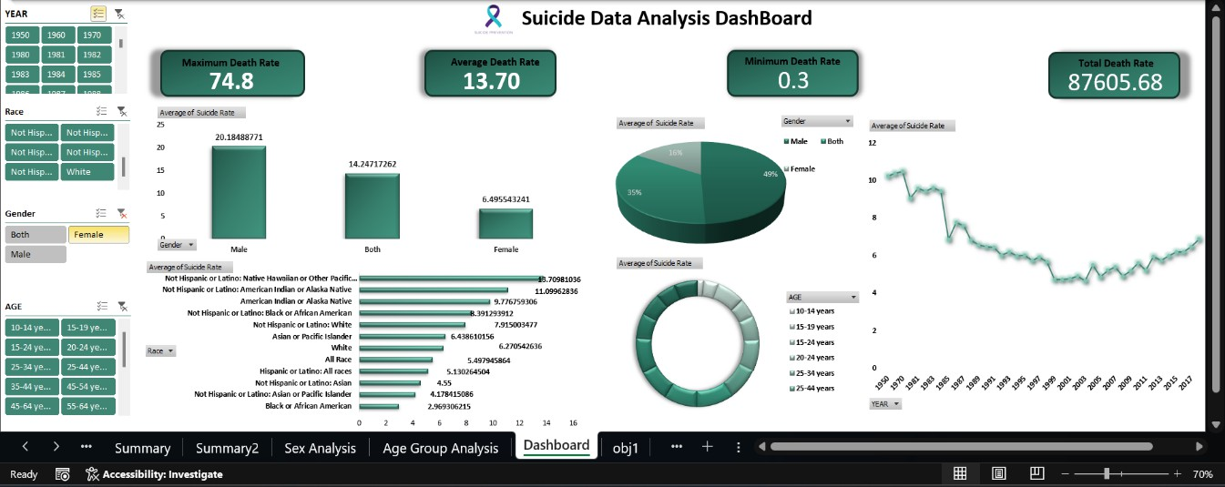
Figure 21: Analyzing data using slicers

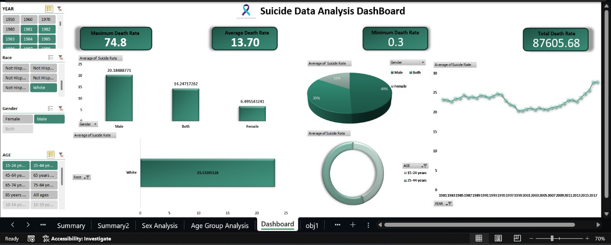

Figure 22: Analyzing data using slicers

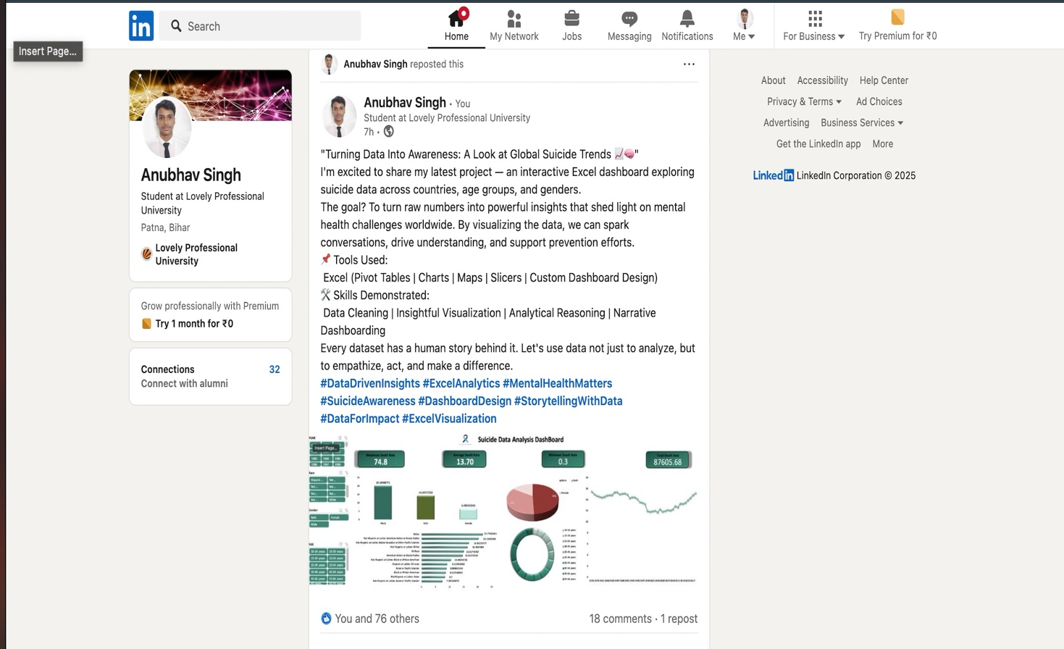

Link of LinkedIn - https://www.linkedin.com/feed/update/urn:li:activity:7316804691277795329/

Chapter 7 - Conclusion

This project provided valuable insights into the suicide rate patterns across different states in the United States. Through the use of Excel tools and techniques, I was able to clean, organize, and analyze the dataset efficiently. The visualizations created using pivot tables and charts helped in representing the data in a user-friendly and interactive way.
The analysis revealed important trends and patterns, such as the higher suicide rates among males compared to females, the vulnerability of certain age groups, and the disparities in suicide rates among different races. The year-wise trend analysis provided an overview of the changes in suicide rates over time, helping in understanding the effectiveness of past health initiatives.
This project also allowed for a detailed examination of how demographic factors influence suicide rates. It was identified that specific races and age groups are more susceptible to higher suicide rates in certain states. Such findings are essential for the development of focused intervention strategies and for spreading awareness about mental health issues.
Overall, this project enhanced my skills in data cleaning, analysis, and visualization using Excel. It demonstrated how large datasets can be transformed into meaningful insights that can aid in decision-making and creating awareness about sensitive social issues like suicide. It also helped me understand the importance of using data to address real-life problems and the value of presenting data visually to communicate insights effectively.
Working on this project provided me with practical experience in handling real-world data, performing exploratory data analysis, and generating an interactive dashboard to support data-driven decisions. This project not only strengthened my technical skills but also highlighted the societal impact of data analysis in addressing crucial public health challenges.

Chapter 8 - Future scope

This project has successfully demonstrated the ability to use Excel as a powerful tool for data cleaning, analysis, and visualization. However, there is significant scope for future enhancements and further research to expand the effectiveness and applicability of this project to a wider audience and real-world use cases.
In the future, the dataset can be expanded to include more recent data from upcoming years for a more current analysis. Additional parameters such as education level, employment status, socio-economic background, mental health history, access to healthcare facilities, and lifestyle factors could be incorporated. Including these parameters would allow for a more detailed and multi-dimensional analysis of the factors contributing to suicide rates across different regions.
Furthermore, advanced data visualization tools like Power BI, Tableau, or Python libraries such as Matplotlib and Seaborn can be integrated for creating more dynamic and visually appealing dashboards. These tools can offer better interactivity, deeper analysis, and real-time data visualization capabilities. Implementing these advanced tools would make the analysis more scalable and user-friendly for a wider audience including healthcare professionals, researchers, and government agencies.
In addition, machine learning techniques and predictive modelling could be applied to forecast future suicide rates based on historical data trends and demographic patterns. Predictive analytics can enable early identification of high-risk individuals or groups, thereby allowing policymakers to implement targeted prevention strategies effectively.
Another important future enhancement could involve real-time data integration from verified sources such as health agencies, government databases, or mental health organizations. This would ensure that the data remains up-to-date, accurate, and relevant for continuous monitoring and proactive analysis.
Collaboration with healthcare providers, educational institutions, and mental health organizations can further enhance the utility of this project. These partnerships can assist in developing targeted awareness campaigns, intervention programs, and preventive strategies based on the insights derived from the data analysis.

Thus, this project lays a strong foundation for future developments and has the potential to evolve into a more comprehensive, scalable, and impactful data-driven tool for public health management, mental health awareness, and strategic decision-making at a national level.

Chapter 9 - References

- United States Government, "Death Rates for Suicide by Sex, Race, Hispanic Origin, and Age — United States," Data.gov. [Online]. Available: https://catalog.data.gov/dataset/death- rates-for-suicide-by-sex-race-hispanic-origin-and-age-united-states-020c1. [Accessed: Apr. 07, 2025].
- https://exceljet.net/excel-pivot-tables. (Accessed on 09th Apr 2025).

- D. Paranjape, "Mastering Data Analysis with Excel," Packt Publishing, 2016.

- Lovely Professional University, "Course Material - INT 217 Introduction to Data Management," School of Computer Science and Engineering, Phagwara, Punjab, 2025.
.

